

Placement Empowerment Program

Cloud Computing and DevOps Centre

**Set Up Git Branching**

Create a new branch in your Git repository for testing. Add a new feature and merge it.

Name:Manashaa U Department: CSE

Introduction:

In this Proof of Concept (POC), I have set up branching in github using various commands

Step-by-Step Overview Step

1. Change the directory

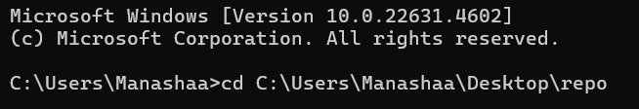

2.Initialize and Create a file 



3.Use “git add .” command 

4.Commit changes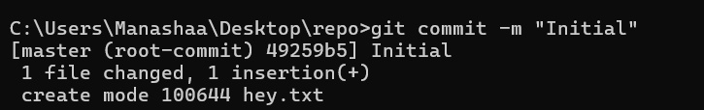

5.Enter checkout command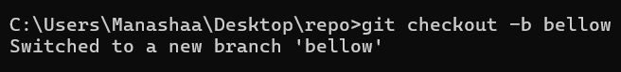

6.Repeat the above steps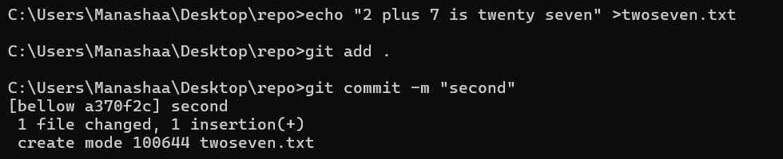

7. use checkout command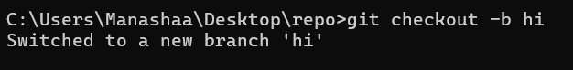

8.Use merge and Delete commands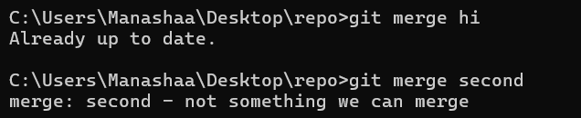

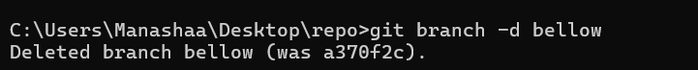

Outcome:

The outcome of creating a new branch, adding a feature, and merging it in Git is a structured and efficient workflow that enhances software development. It allows for safe testing and experimentation without disrupting the main codebase. Once merged, the new feature becomes part of the main branch, ensuring an organized and controlled integration of changes. This approach also improves collaboration among developers, reduces conflicts, and maintains a clear version history, making it easier to track modifications.